Chest x-ray data for predicting pneumonia or healthy
T. Akhila
Machine Learning Intern
AI Technology and Systems
akhila1998akhila@gmail.com
www.ai-techsystems.com
www

Abstract— This is the study proposes a convolutional neural network model trained from scratch to classify and detect the presence of pneumonia from a collection of chest X-ray image samples. Unlike other methods that rely solely on transfer learning approaches or traditional handcrafted techniques to achieve a remarkable classification performance, I constructed a convolutional neural network model from scratch to extract features from a given chest X-ray image and classify it to determine if a person is infected with pneumonia. This model could help mitigate the reliability and interpretability challenges often faced when dealing with medical imagery.
Keywords—Machine-learning,CNN(convolution neural networks), keras.

INTRODUCTION

The risk of pneumonia is immense for many, especially in developing nations where billions face energy poverty and rely on polluting forms of energy. The WHO estimates that over 4 million premature deaths occur annually from household air pollution-related diseases including pneumonia. Over 150 million people get infected with pneumonia on an annual basis especially children under 5 years old. In such regions, the problem can be further aggravated due to the dearth of medical resources and personnel.
CNNs have an edge over DNNs by possessing a visual
processing scheme that is equivalent to that of humans and extremely optimized structure for handling images and 2D and 3D shapes, as well as ability to extract abstract 2D features through learning. The max-pooling layer of the convolutional neural network is effective in variant shape absorptions and comprises sparse connections in conjunction with tied weights.

EXISTING SYSTEM
The existing system is actually tedious work because a person has to manually sit and continuously record all the information. This may be easy when dealing with few records but when there are millions of records to be updated then this process is not worthy. Using deep learning, we can get more efficient and accurate results. In existing system, if the testing was made manually it could take many days to get the result whether the person has the disease or not. Finally, deep learning method improved accuracy when compared to rule-based methods. Deep neural network models have conventionally been designed, and experiments were performed upon them by human experts in a continuing trial-and-error method. This is process demands enormous time,know-how, and resources. In recent times, CNN-motivated deep learning algorithms have become the standard choice for medical image classifications although the state-of-the-art CNN-based classification techniques pose similar fixated network architectures of the trial-and-error system which have been
their designing principle

PROPOSED SYSTEM

To overcome the issues faced with existing system, we want to develop a system which can identify the disease within fraction of seconds accurately. The solution is to make use of CNN(convolution neural network).Convolutional neural network (CNN) is a class of deep neural networks that specializes in analyzing images and thus is widely used in computer vision applications such as image classification and clustering,object detection, and neural style transfer.We use binary classification technique to classify the data into normal and pneumonia. Binary or binomial classification is the task of classifying the elements of a given set into two groups on the basis of a classification rule. Contexts requiring a decision as to whether or not an item has some qualitative property, some specified characteristic,or some typical binary classification include: Medical to determine if a patient has certain disease or not –the classification property is the presence of the disease.
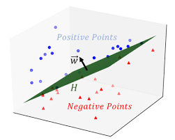
IMPLEMENTATION

Experiments were based on a chest X-ray image dataset. We deployed Keras open-source deep learning framework with TensorFlow backend [to build and train the convolutional neural network model.
NUMPY: This package can be used to perform operations like converting an image into vectors or matrices. (As the dataset contains images as the input samples, we need to convert such samples into matrices)
KERAS: It is one of the vital packages because using Keras we can build a neural network model which learns the data samples. Keras is an open source library for building neural network model.
MATPLOTLIB: This package is exclusively used for visualizing the data. The trends and patterns in the dataset can be graphically visualized by using the package.
Dataset:-The original dataset consists of three main folders (i.e., training, testing, and validation folders) and two subfolders containing pneumonia and normal chest X-ray images, respectively. A total of 5,856 X-ray images.
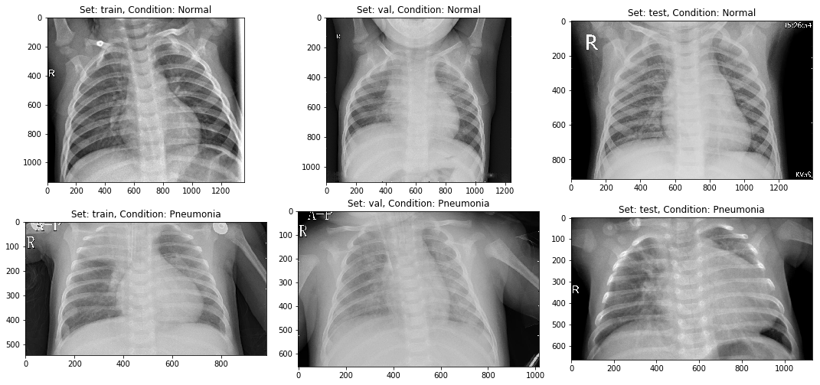

Preprocessing and Augmentation:- We employed several data augmentation methods to artificially increase the size and quality of the dataset. .is process helps in solving overfitting problems and enhances the model’s generalization ability during training.

Model:-The overall architecture of the proposed CNN model which consists of two major parts: the feature extractors and a classifier (sigmoid activation function). Each layer in the feature extraction layer takes its immediate preceding layer's output as input, and its output is passed as an input to the succeeding layers.
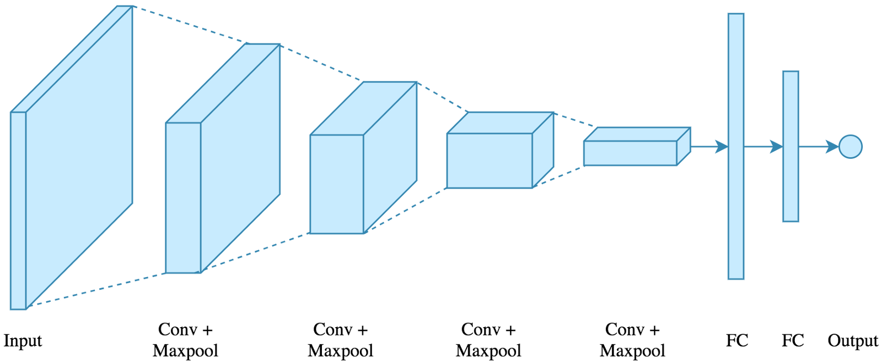
The classifier is placed at the far end of the proposed
convolutional neural network (CNN) model. It is simply an artificial neural network (ANN) often referred to as a dense layer. This classifier requires individual features (vectors) to perform computations like any other classifier. Therefore, the output of the feature extractor (CNN part) is converted into a 1D feature vector for the classifiers. .is process is known as flattening where the output of the convolution
operation is flattened to generate one lengthy feature vector for the dense layer to utilize in its final classification process. The classification layer contains a flattened layer, a dropout of size 0.5, two dense layers of size 512 and 1, respectively, a RELU between the two dense layers and a sigmoid activation function that performs the classification tasks.
After fitting the model, we get the below result:-
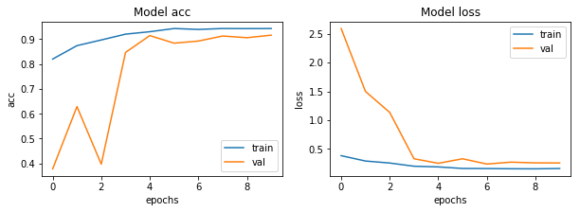

Results

As explained above, methods such as data-augmentation, learning rate variation were deployed to assist in fitting the small dataset into deep convolutional neural network architecture.
The final results obtained testing accuracy is 91.02564102564102%, training accuracy is 94.23, and the F1
score is 93.08641975308642.

CONFUSION MATRIX ------------------
[[191 43]
[ 13 377]]

TEST METRICS ----------------------
Accuracy: 91.02564102564102%
Precision: 89.76190476190476%
Recall: 96.66666666666667%
F1-score: 93.08641975308642

TRAIN METRIC ----------------------
Train acc: 94.23

References

1)."Keras backends". keras.io. Retrieved 2018-02-23.
2).Wikipedia:-https://en.wikipedia.org/wiki/Binary_classification

